­

­

2021

System Design Application

Supri Bin Hj Amir

**Sozo Lab Task-1**

**System Design Application**

**Application Name: Apps Seminar**

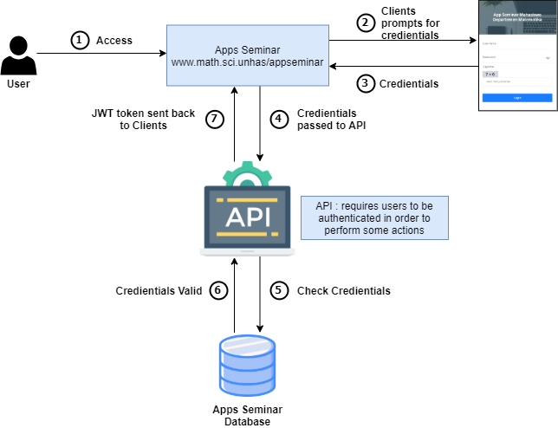

**Activity Diagram**

**Database Design**